**University Blog Platform**

Done By:

Menaka Naga Sai Pothina(700772418)

Mandoji Sai Tejaswi(700758342)

Gali Udaya Rekha Chowdari(700774490)

Kadthala Udayasri(700762361)

# **Project Description:**

The University Blog Platform is an online space for university members to discuss, share knowledge, and collaborate on various topics. It is organized into "Rooms," which are customizable spaces where users can talk about academic subjects or personal hobbies. These Rooms cover a wide range of topics, from university courses to extracurricular activities like sports, making it useful for different interests.

A key feature of the platform is the academic Rooms, which focus on specific subjects. These Rooms allow students and teachers to share materials, discuss assignments, and study together. Additionally, the platform includes Sports Rooms where users can talk about sports like football or basketball, share strategies, and discuss team updates.

There are two main roles on the platform: Admins and Owners. Admins manage the entire platform, ensuring it runs smoothly and that rules are followed. They can block or unblock users who break the rules. Owners manage specific Rooms, approving or rejecting members, moderating discussions, and ensuring respectful behavior. Owners can block or unblock posts in their Rooms but cannot block users.

Room Members, who join based on their interests, drive the discussions. They can post text, images, videos, or links, allowing for rich interactions. For example, a student might share a video tutorial or post an academic article in a course Room. There is also a rating system where users can like or dislike posts to highlight valuable contributions.

In summary, the University Blog Platform provides an organized and interactive space for academic and extracurricular discussions. It uses clear roles, easy content-sharing options, and guidelines to encourage teamwork while keeping the community positive and respectful.

# **Database Description:**

In this **University Blog Platform** we have seven collections: admin, room_category, room, room_members, member, polls and post collections.

The admin collection is made to support admin. Such users manage the entire platform, and each admin has a unique admin_id detected through the username and password. These details will be stored in the admin collection.

The room_member will register on the website with his details, like owner_name, email, phone, password, state, city, zip_code and members[ ]. This data will be stored in the room_member collection. After registration, the room_member will be logged into the website with a registered email and password.

The admin can add the room_categories with room_category. This data will be stored in the room_categories collection.

After that the admin will add the rooms based on room categories with details like room_title, description, created_on, created_by, status and by selecting room_member. Here the room_category_id and room_member_ids are the reference keys. This data will be stored in the rooms collection.

The room_member can add and view the list of posts in rooms with details like title, image, video, status, likes[ ], comments[ ] and room_id. Here room_id is the reference key in this post collection. This data will be stored in the posts collection.

The member will register on the website with his details, like first name, last name, email, phone, password, state, city, zip_code.This data will be stored in the member collection. After registration, the member will be logged into the website with a registered email and password.

In the polls collection we have post_id, member_id, room_member_id, question, answers[ ] and submitted_count. Here post_id,member_id,room_member_id are the reference keys. These data will be stored in polls collection.

# **Document Data Model:**

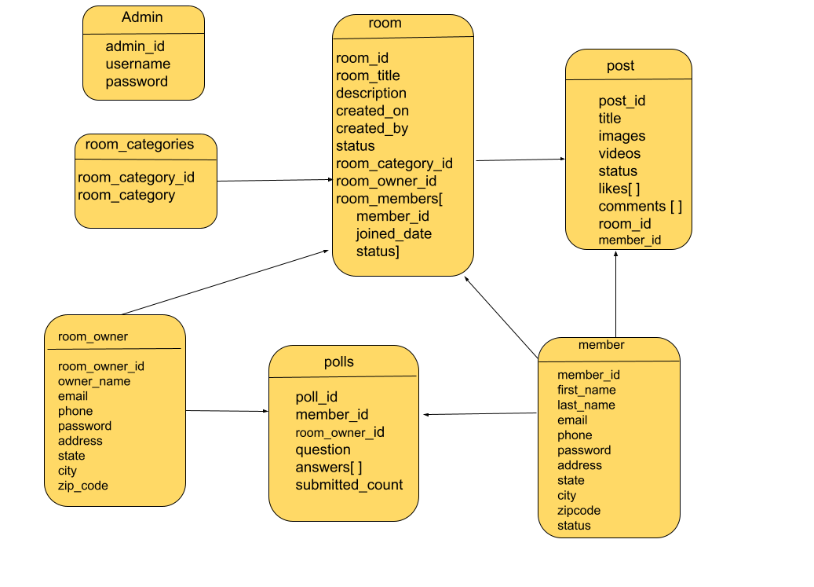

**Database Collections:**

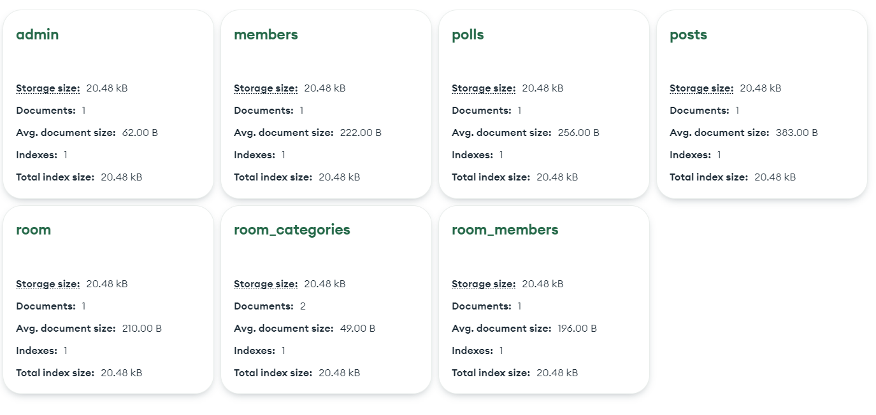

**Sample Snippets:**

**Admin collection:**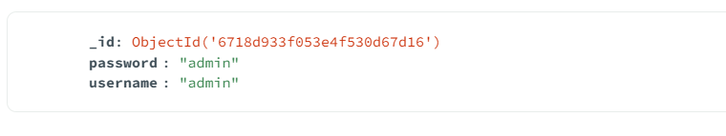

**Room Members collection:**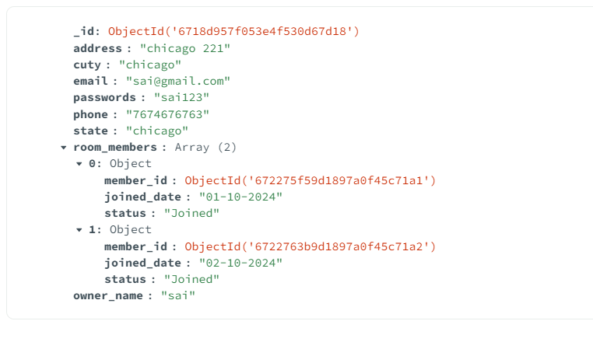

**Room category collections:**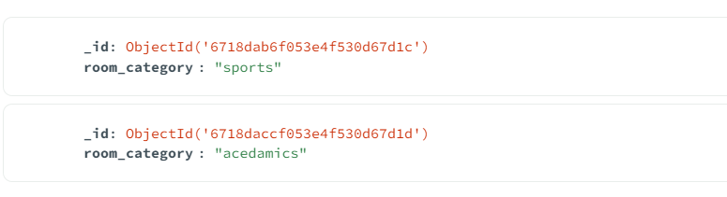

**Room collections:**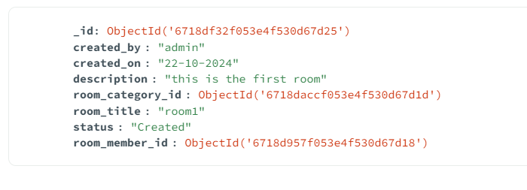

**Members collection:**

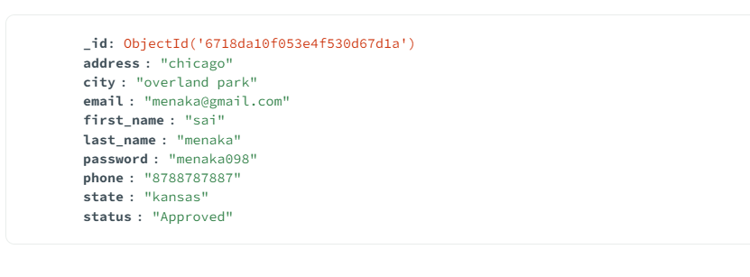

**Posts collection:**

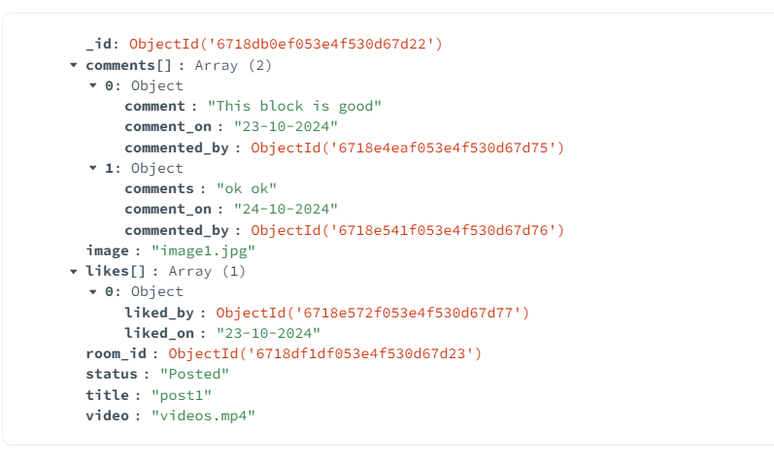

**Polls collection:**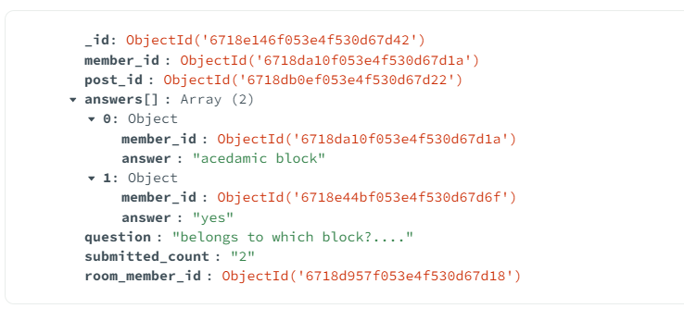

**Home page**

* This is a home page.

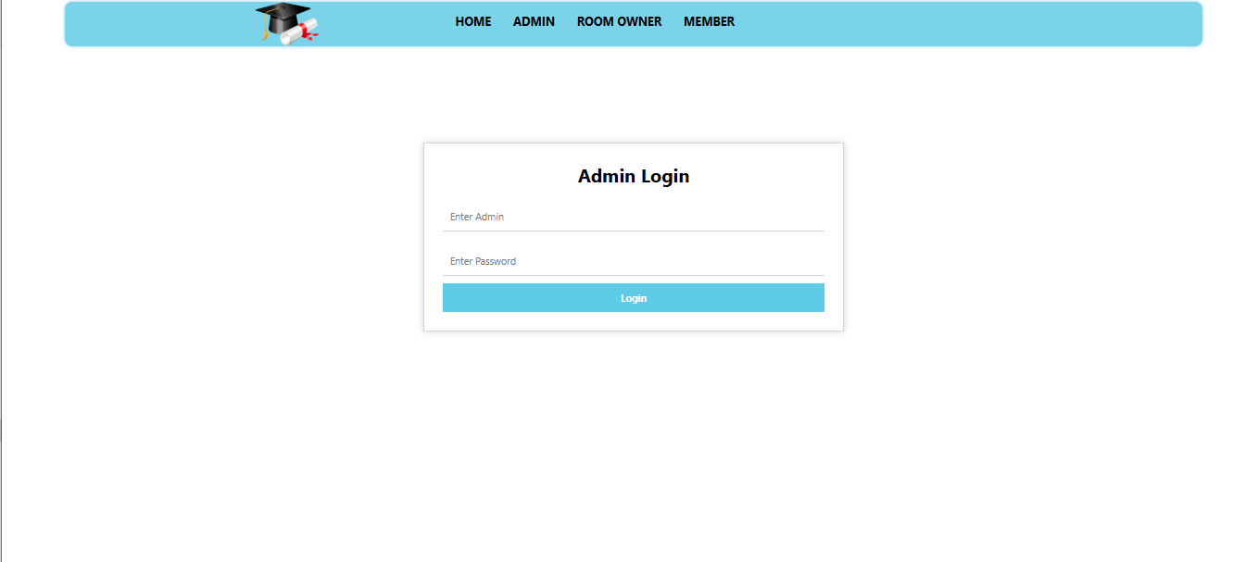**Admin login page**

* This admin login page.

**Admin home page**

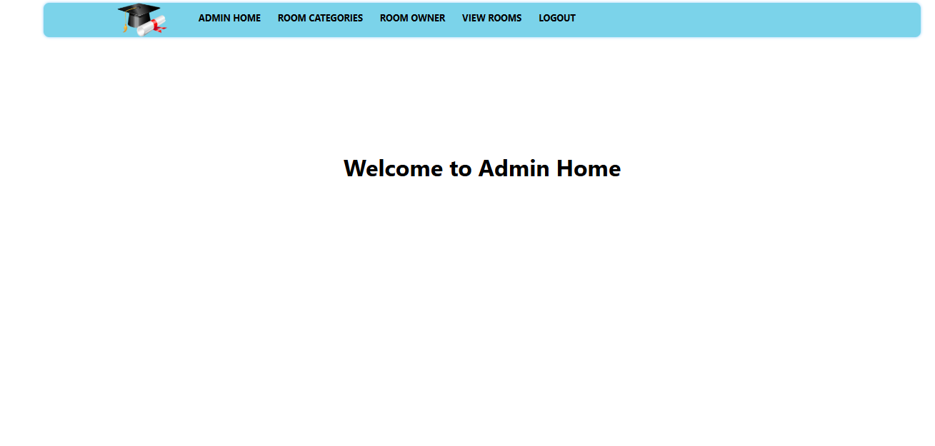

* This is the admin home page.

**Add and view room categories**

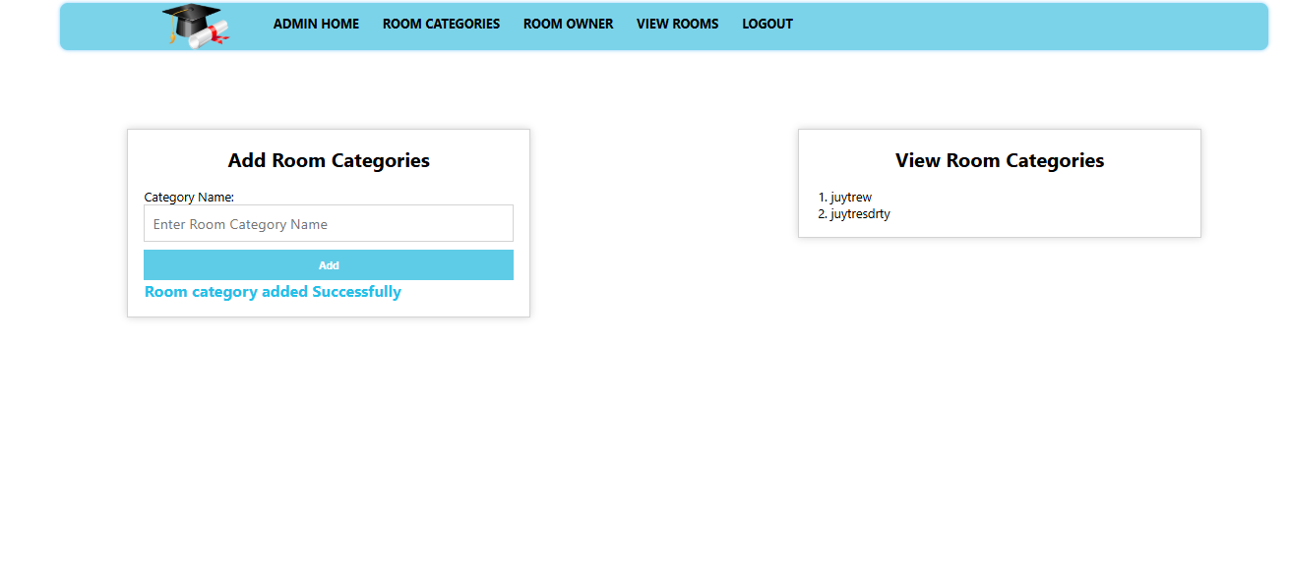

* Add and view the room categories.

**Add and view room owners**

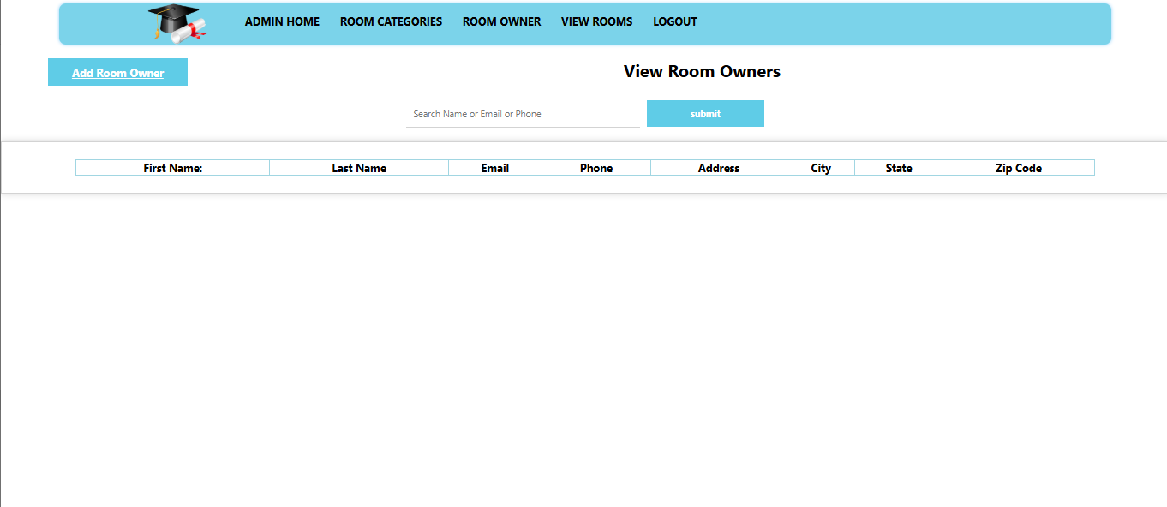

* Admin to click the add room owner button.

**Room owner registration page**

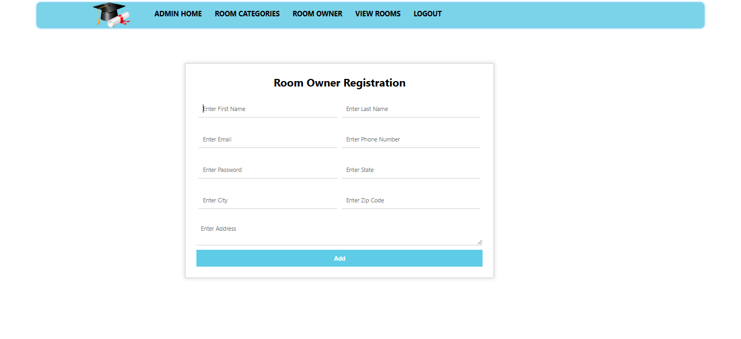

* Admin to click the add room owner button. To display the room owner registration page.

**View room owners**

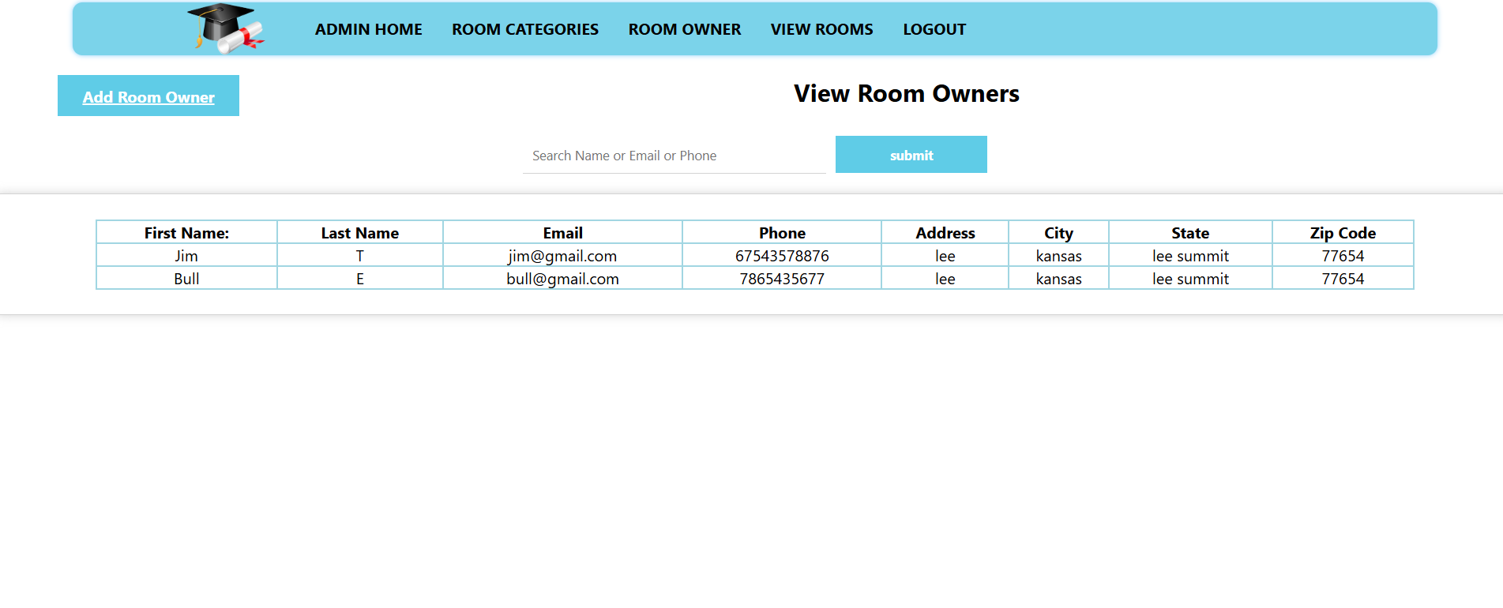

* view room owners details list.

**Search with view particular owner**



* If a particular owner searches for an email or phone or name to view the details.

**Admin add rooms**

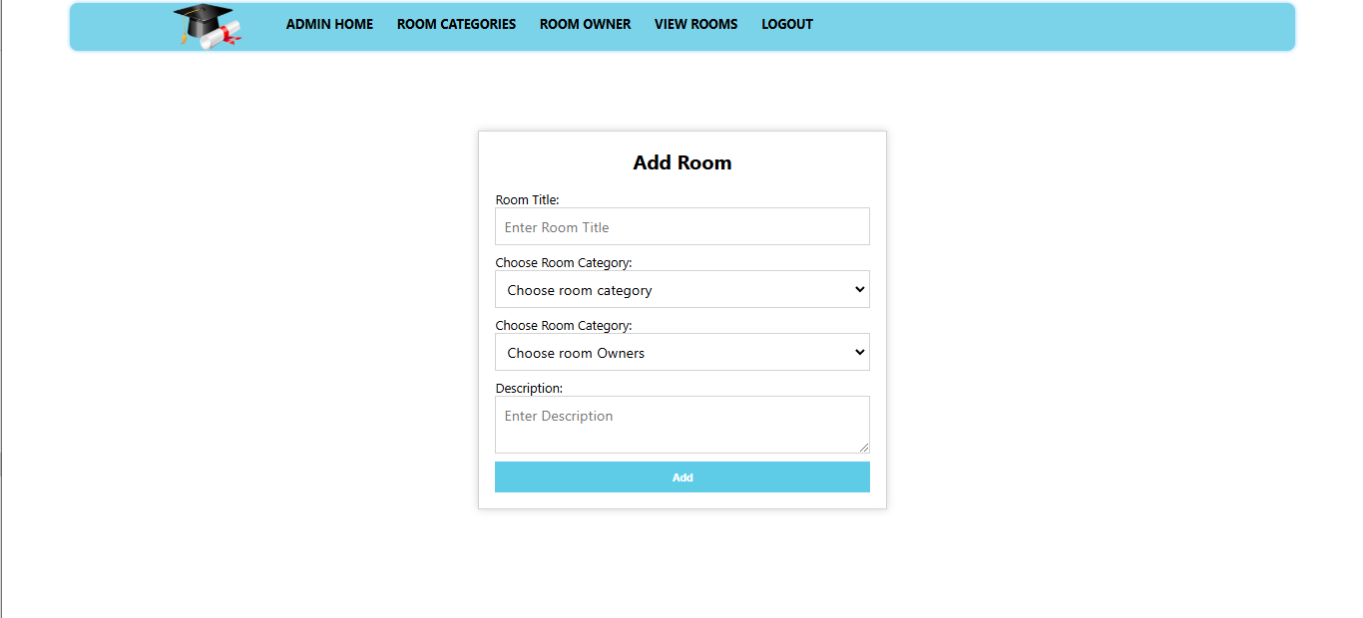

* Admin to added rooms.

**View rooms**

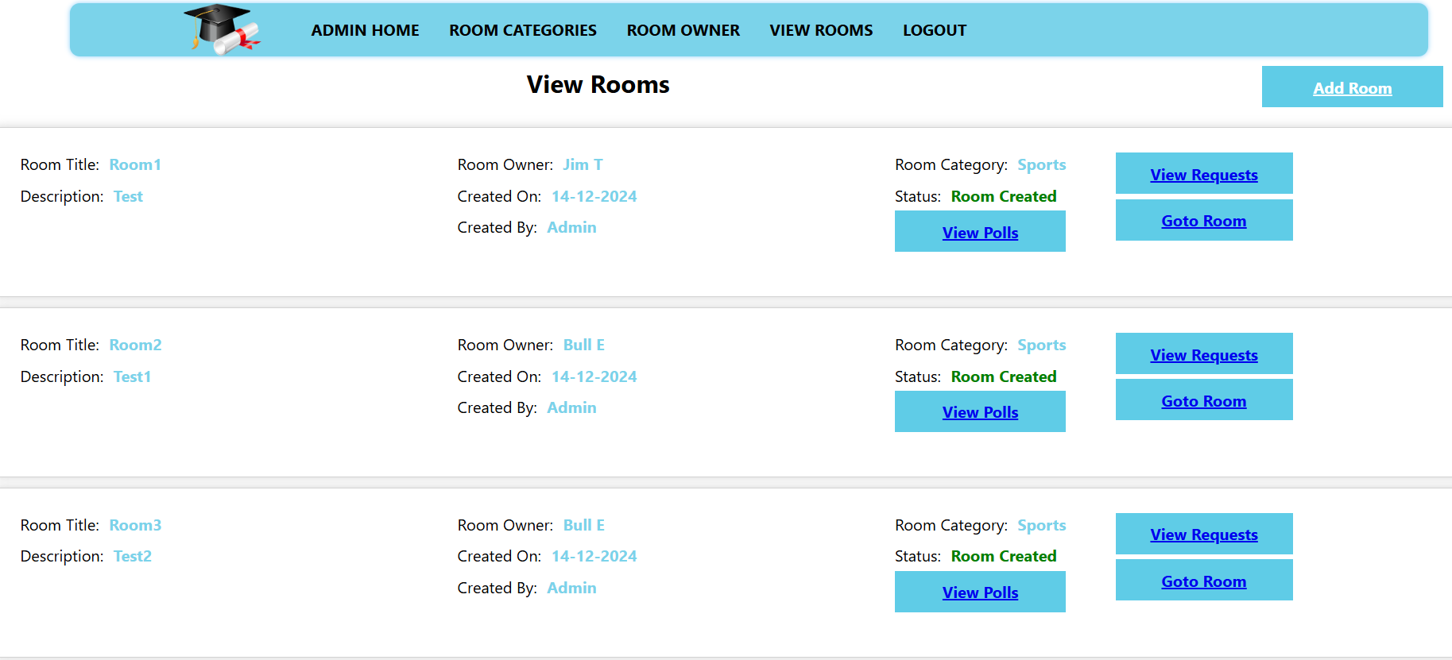

* View the room details.

**Room owner login page**

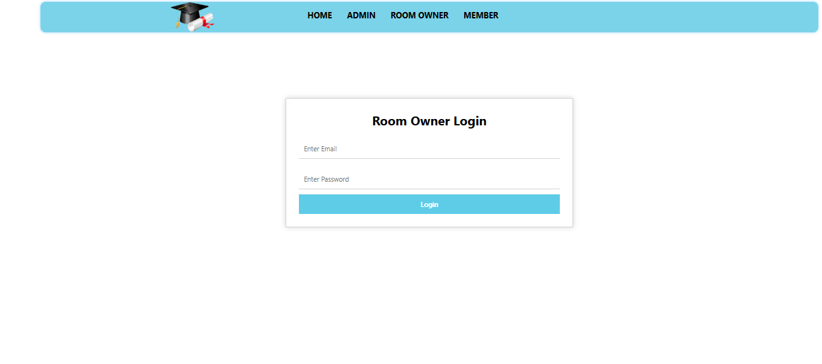

* This is a room owner login page.

**Room owner home page**

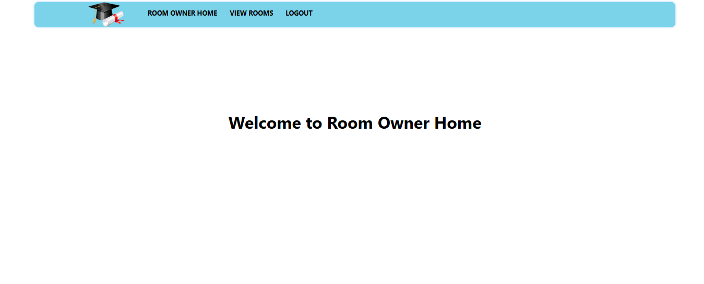

* It is a room owner home page.

**Room owner view rooms**

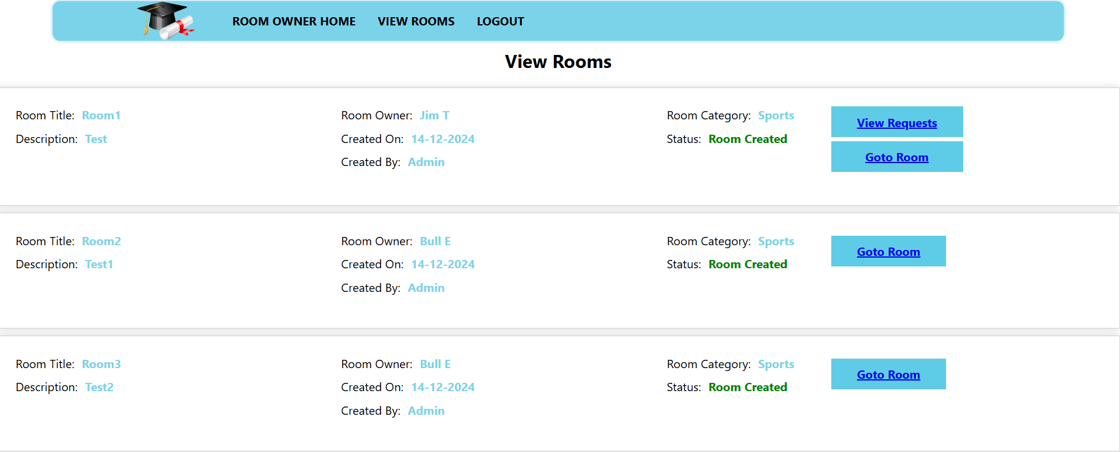

* The room owner can view the room details.

**Member registration page**

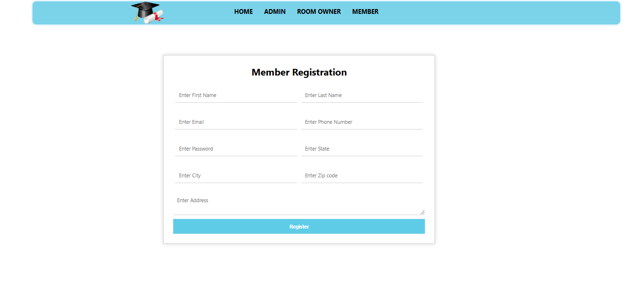

* It is a member registration page.

**Member login page**

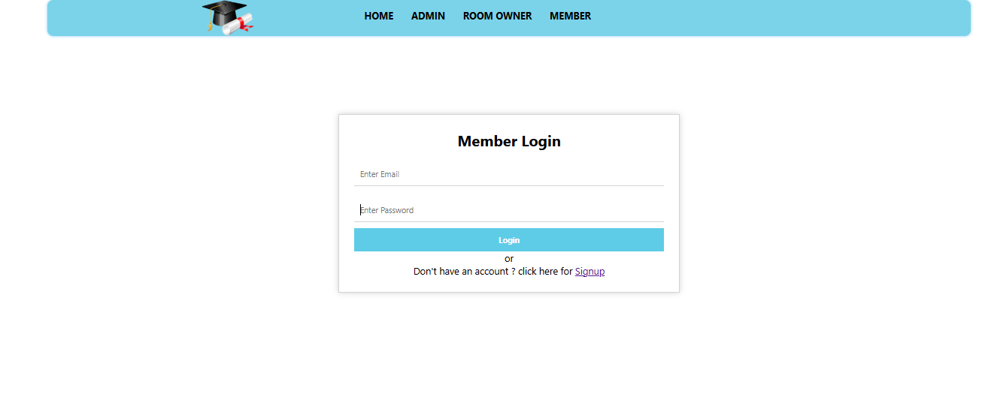

* This is a member login page.

**Member home page**

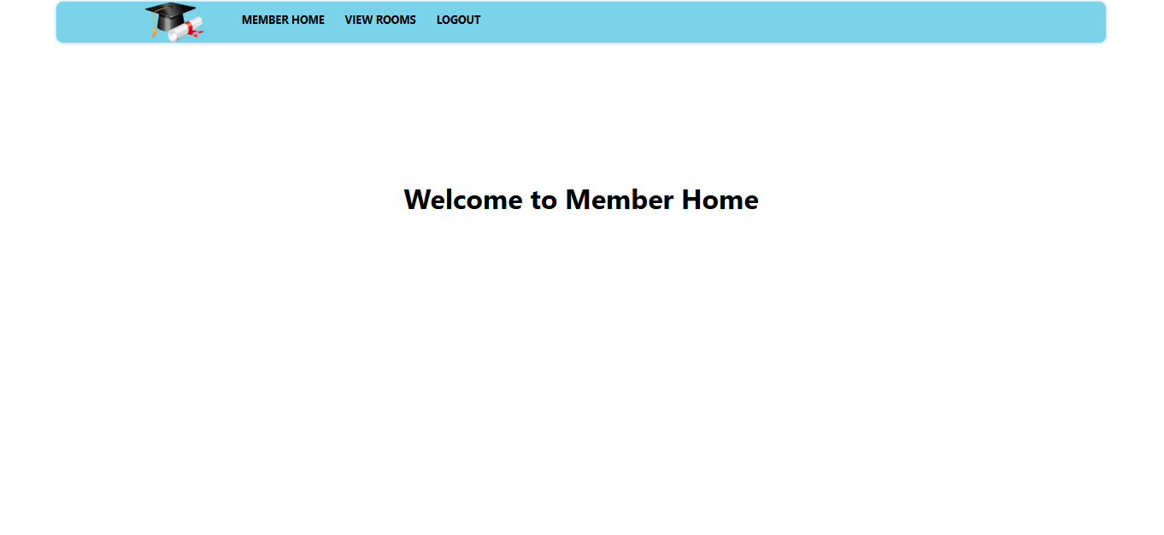

* This is a member home page.

**View rooms**

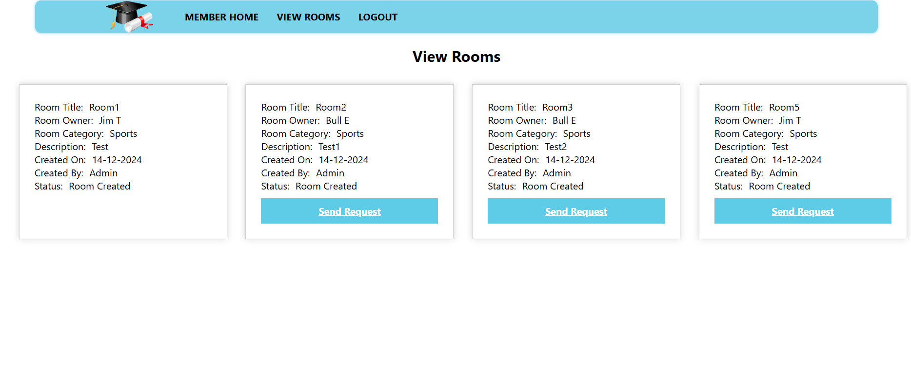

* Member to view the room owner details. Member to send a request to particular room owner.

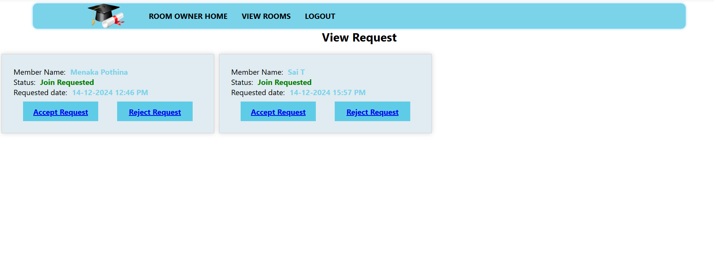**View requests**

* Room owner to view the member send requests. Room owner to accept and reject the requests.

**Block member button**

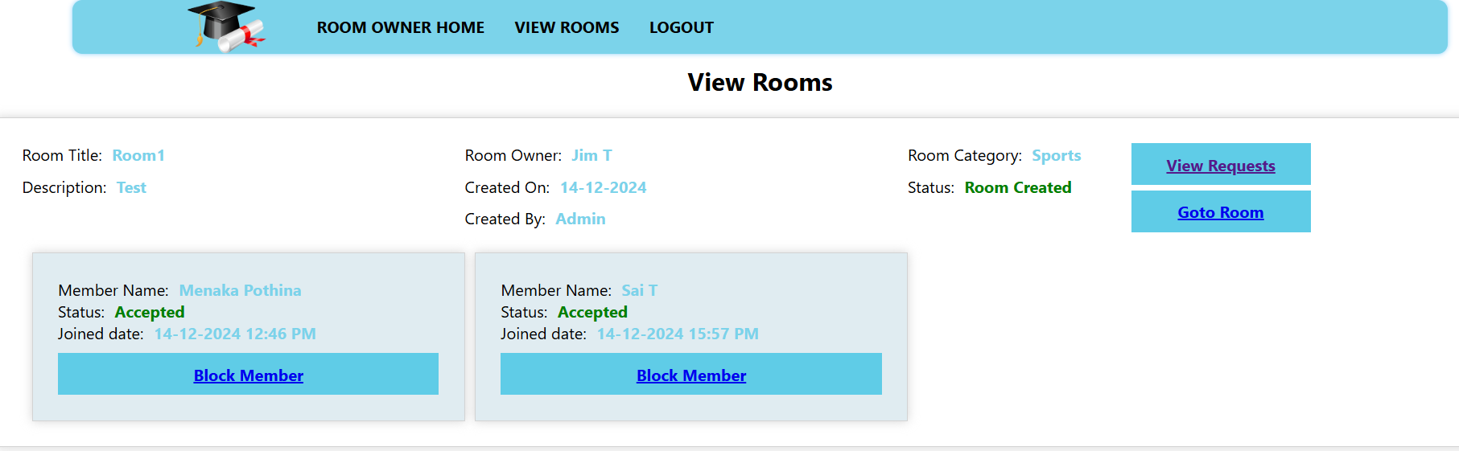

* Room owner to accept the request to display the block member button.

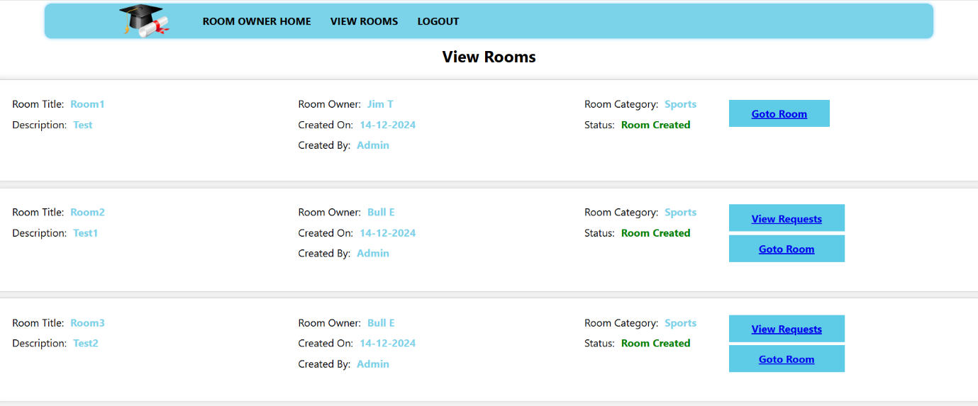**View request button**

* The room owner rejected the request to not change the view room page.

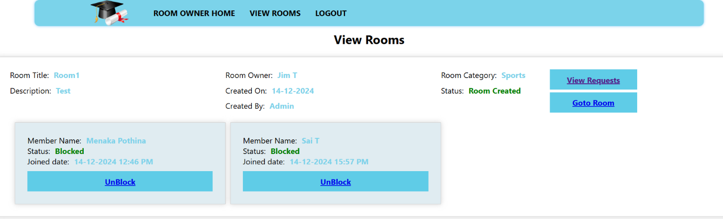**Unblock room**

* The room owner booked a member.

**Room page**

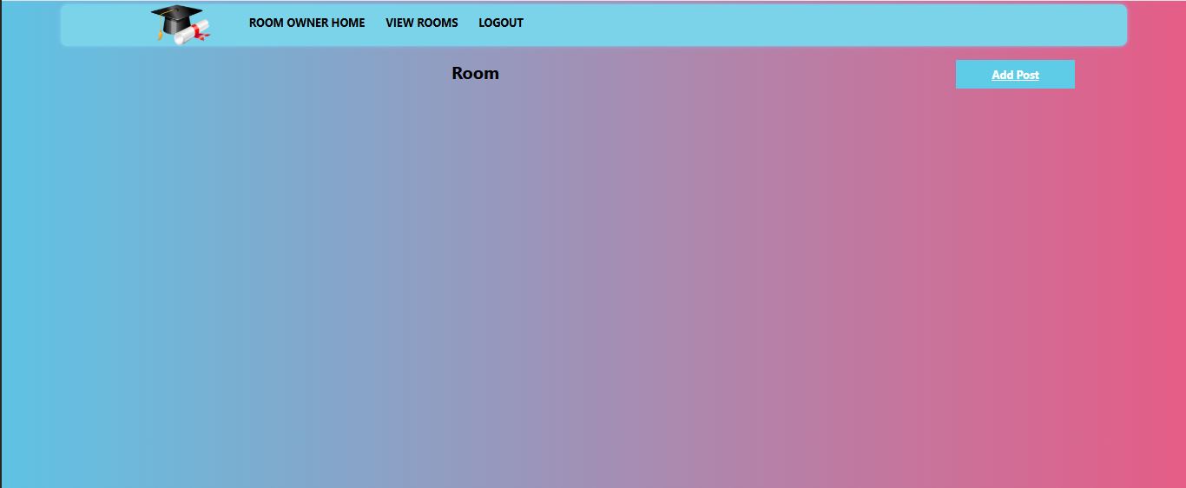

* Room owner to view the member post and add the post.

**Add post**

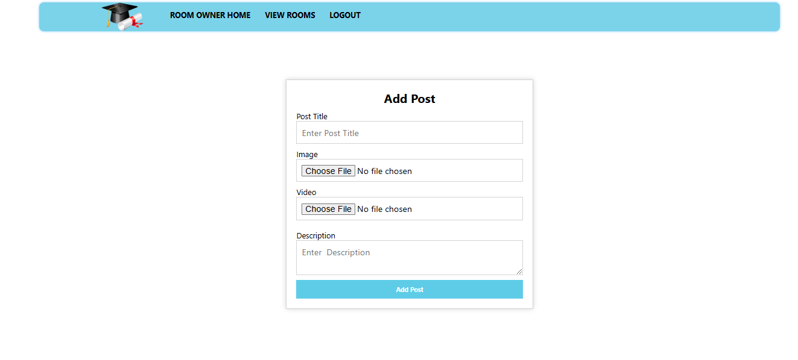

* Room owner to enter the add post details.

**Add and view room image**

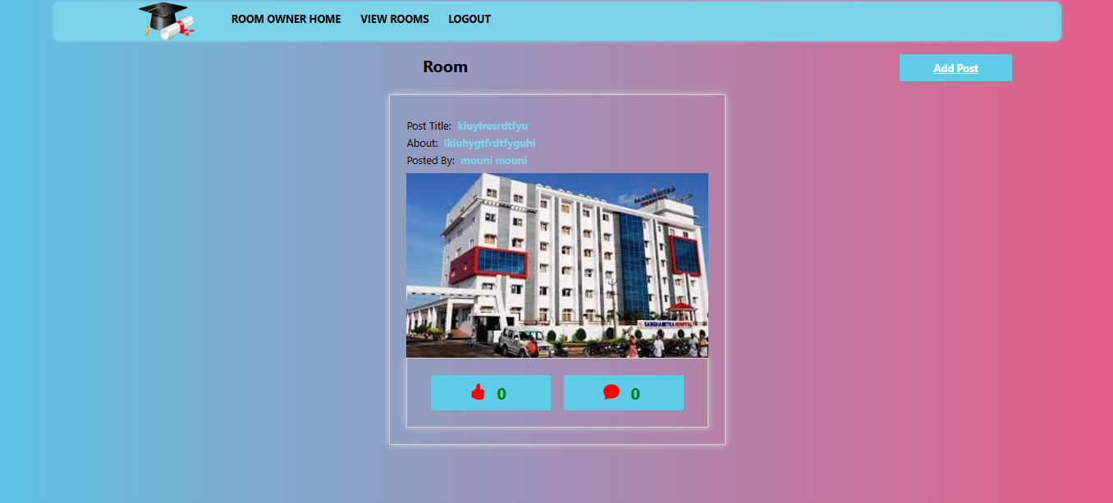

* To view the room details.

**View likes in rooms**



* Liked to the details.

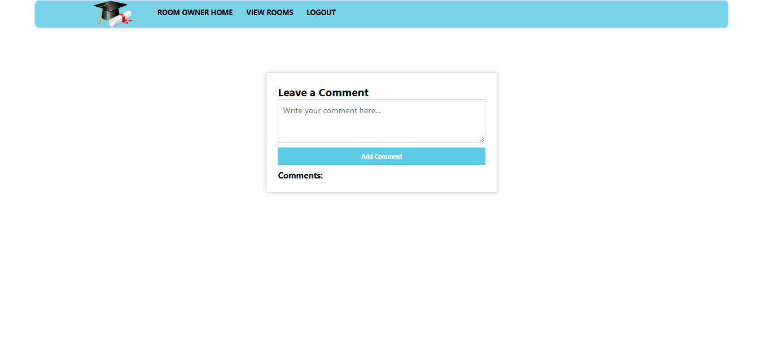**Leave comment**

* To leave a comment.

**Display comment page**

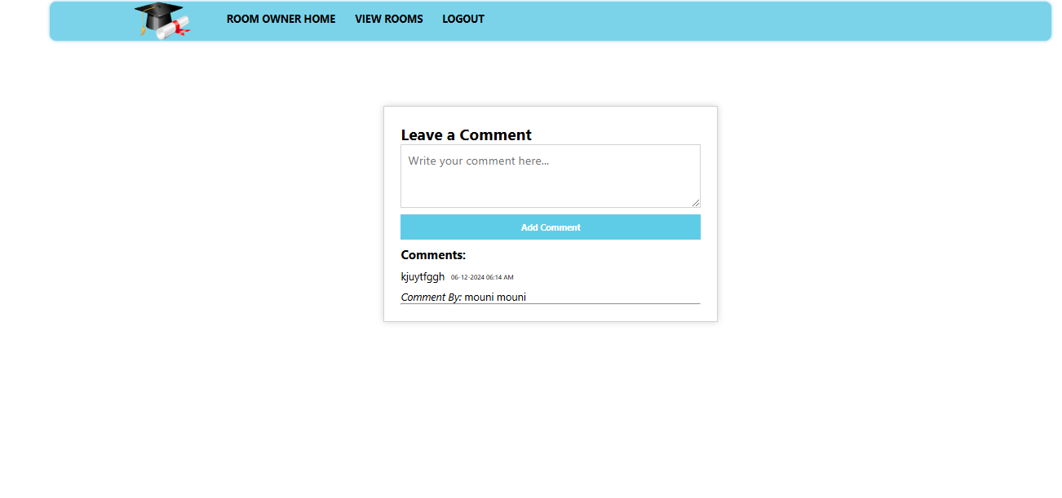

* To display the comment.

**View room details**

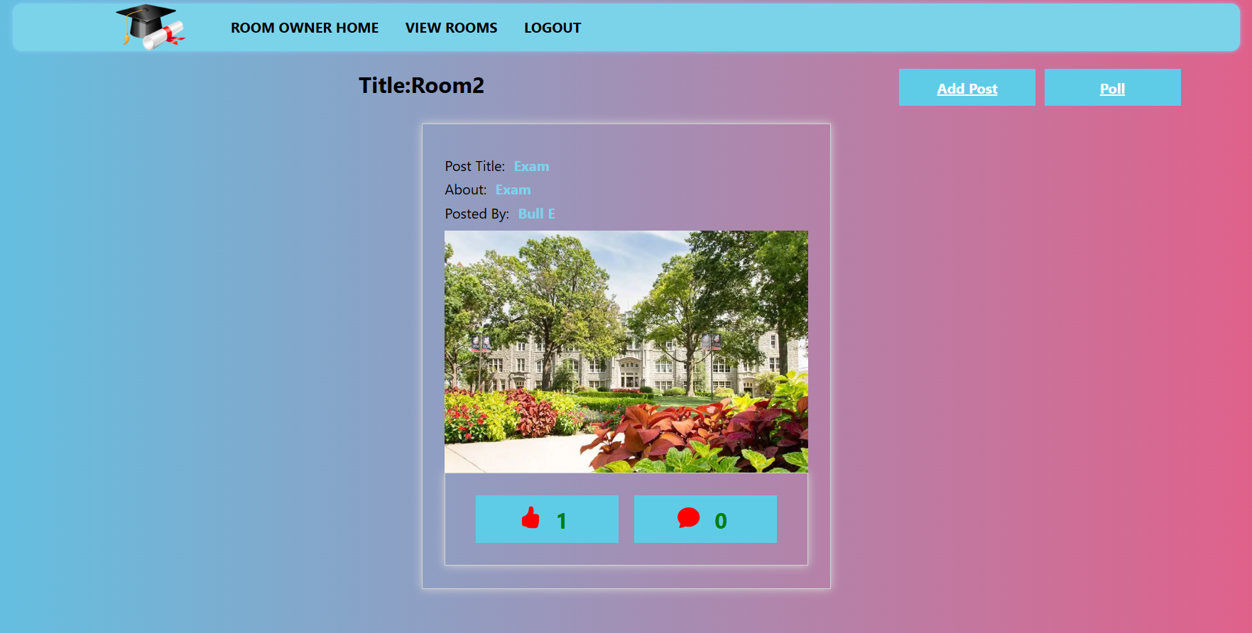

* By clicking the button go to the room and view the room details.

**View polls**

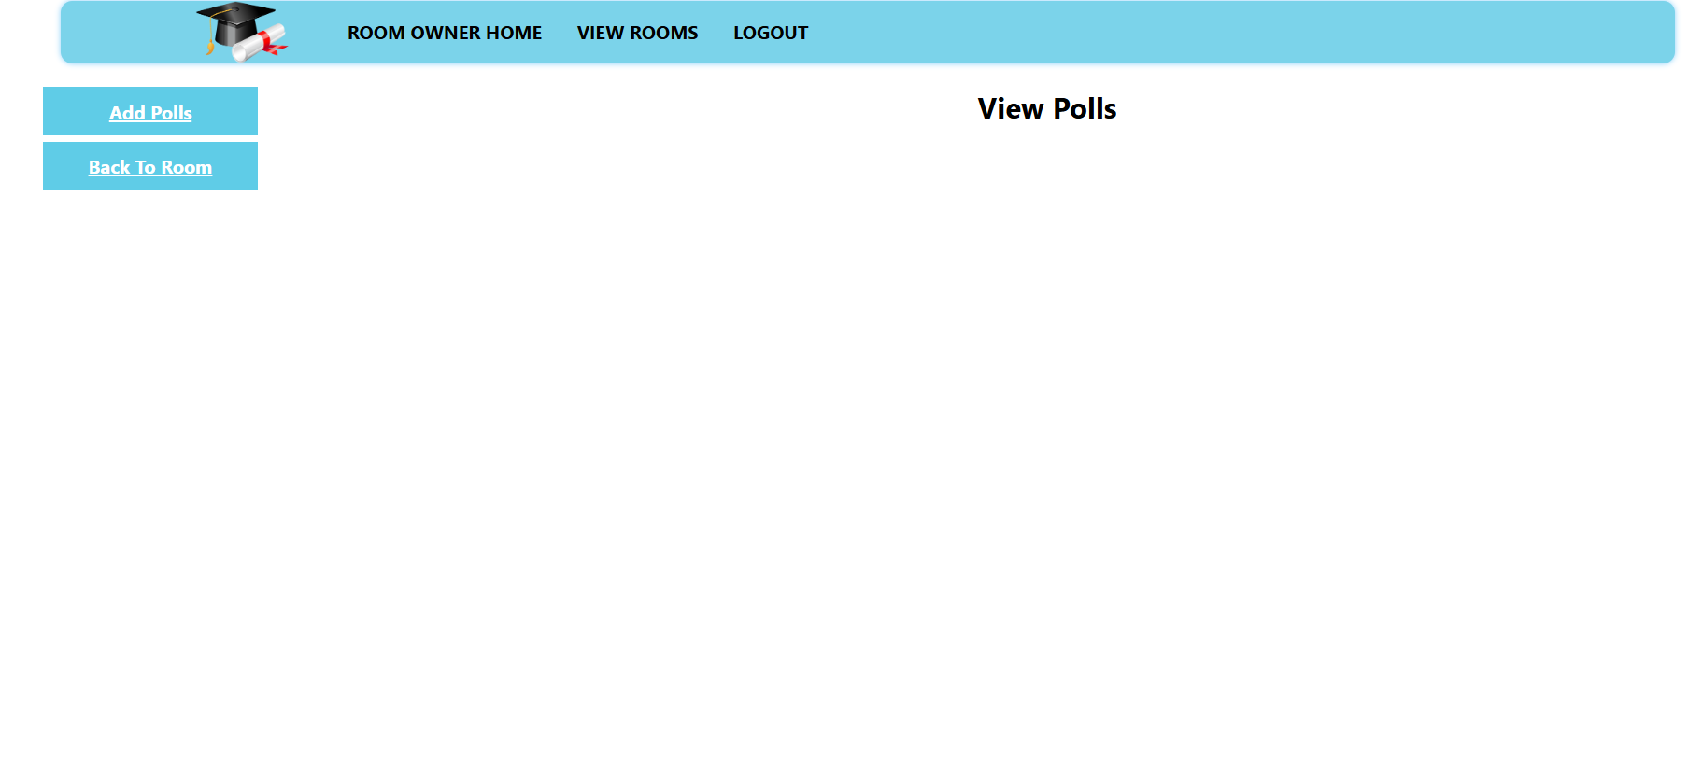

* Add and view the polls.

**Add Poll**

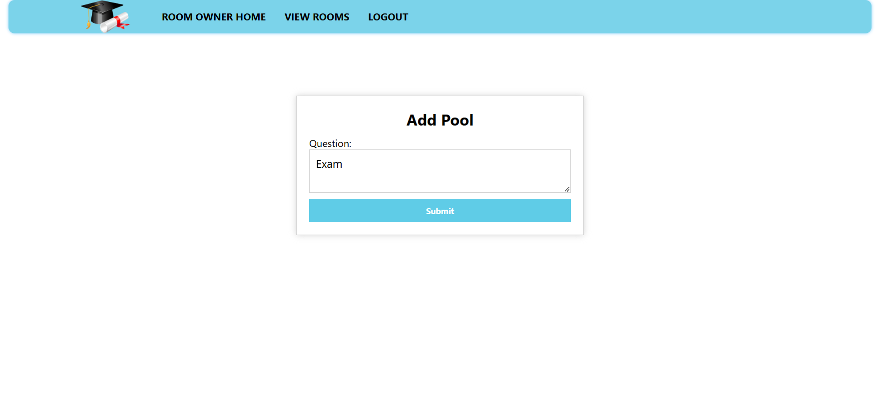

* To ask any questions.

**View poll questions**

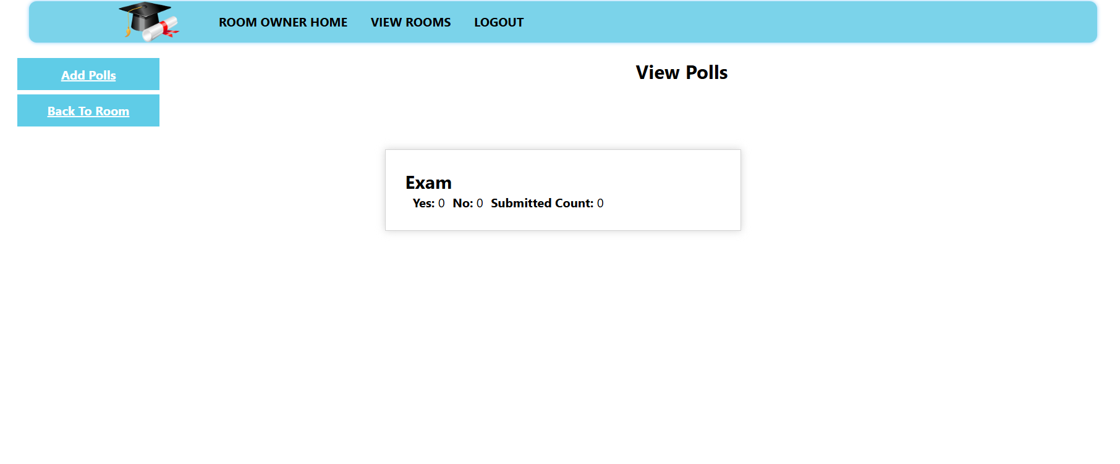

* To view the question.

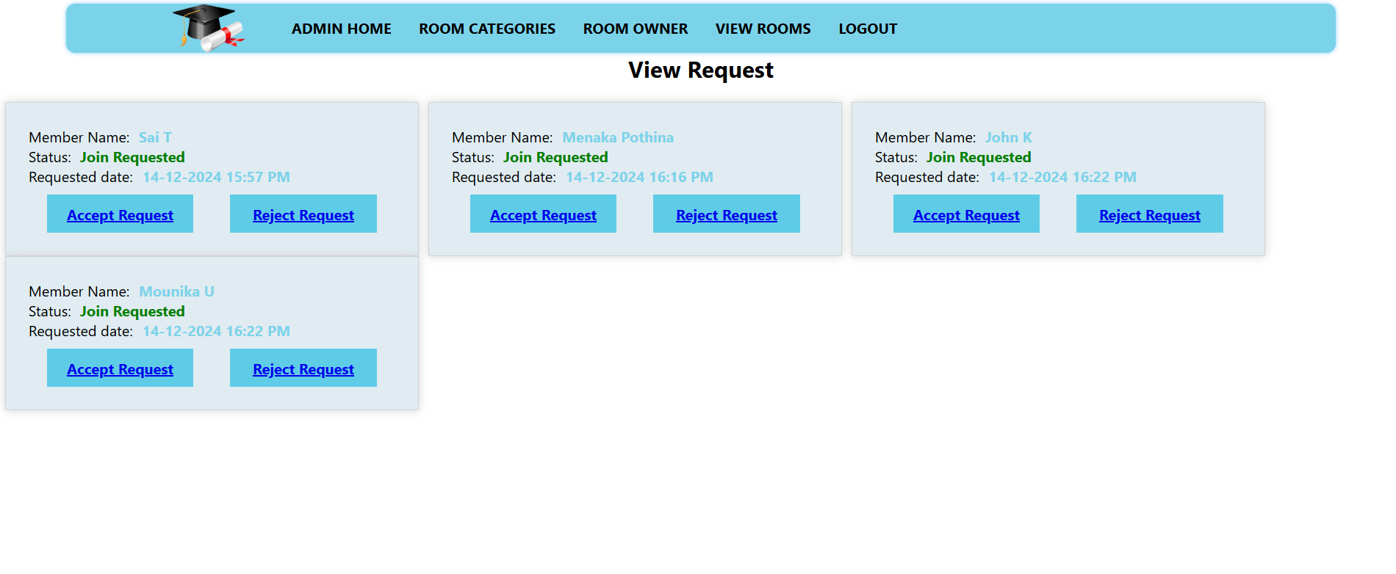**Member requests**

* Admin also to view the member requests.

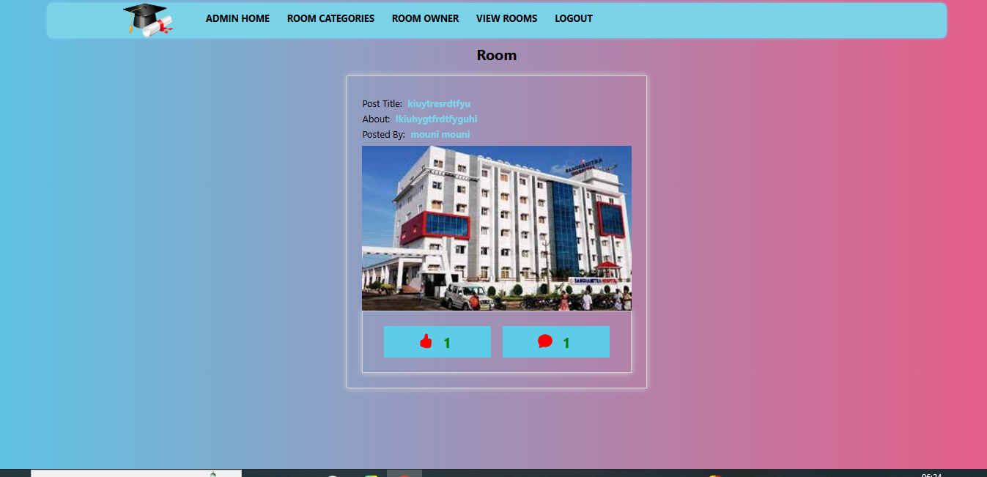**Admin view rooms**

* Admin also to view the room details.

**Admin view polls**

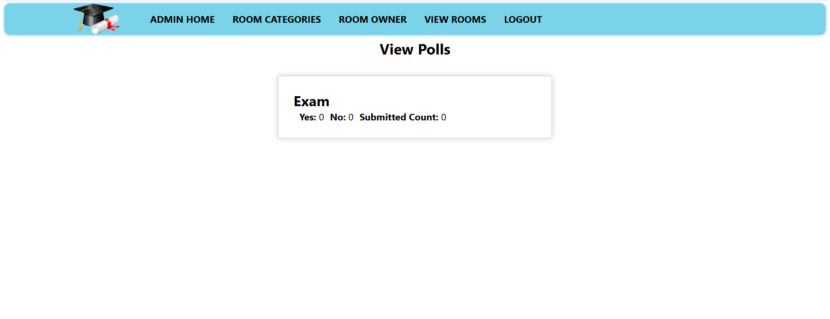

* Admin also to view the polls

**Source Code and Nosql Commands:**

